**Analyzing Microsoft’s Quarterly Valuation: 2010-2023 Using a Three-hypothesis Test** **Framework**

Project Phase-II

2024.03.10

**Part A**

**Analyzing Microsoft’s Quarterly Valuation: 2010-2023 Using a Three-hypothesis Test** **Framework**

**Introduction:**

The analysis aims deeper to uncover patterns, variances, and events that influenced Microsoft's growth over time using a three-hypothesis test framework. The data includes quarterly revenue and profit figures, mean, standard deviation, boundary number, etc. which helps dive deeper into the analysis. We test the claim that the true average profit for the whole population is 30 t alpha 0.001, 0.005, and 0.10.

**Methodology:**

**Hypothesis Testing Framework**

Null Hypothesis (H0): the true average profit for the whole population is 30.

Alternative Hypothesis (Ha): the true average profit for the whole population is not 30.

**Significance Levels**

* 1% (α = 0.01)
* 5% (α = 0.05)
* 10% (α = 0.10)

**Claimed hypothesis and the one you aim to test.**

The claimed Hypothesis is the null Hypothesis.

The alternative hypothesis is the one we aim to test.

**Type of Analysis**

T-Test: Given the data is normally distributed and the sample size is large enough, testing for two-tailed, left-tailed, and right-tailed.

**Results and Discussions**

The choice of a three-hypothesis test framework for analyzing Microsoft's financial data from 2010 to 2023 is motivated by several key objectives:

**Objective: Evaluate financial performance over time**

The first objective is to evaluate Microsoft's financial performance, by testing the null hypothesis, we claim to check the profit growth of Microsoft over 13 years.

Objective 2: Identify significant changes in financial performance, we aim to also evaluate and identify any significant changes in profit trends. By establishing a null hypothesis, we want to test whether these metrics remain constant over time.

**Demonstration Objective: Three hypothesis testing framework is designed to prove the following:**

**Trend analysis:** By performing this test we aim to demonstrate the trend in Microsoft's financial performance over this period. This can help understand whether Microsoft has experienced a period of growth, decline, or continued fluctuations in its financial situation.

**Significance of the relationship:** By testing the null hypothesis, we determine whether the observed changes are due to random fluctuations or significant changes in the company's financial position.

In summary, the framework tests three selected hypotheses to provide a comprehensive analysis of Microsoft's financial performance for the period 2010-2023 with focus on the profit , assess general trends, identify significant changes, and assess the impact of the dynamics of important events and strategies. This approach aims to provide an in-depth understanding of Microsoft's financial situation and the factors that have influenced the company's financial trajectory over the past decade.

**Test Framework:**

Constant Variables

|  |  |
| --- | --- |
| Mean | $20.39 |
| Size | 55 |
| Degree of Freedom | 200000 (when n is equal to or more than 30, we assume the sample is normally distributed) |
| Standard Deviation | $8.31 |
| Boundary number | 30 |
| Standard Error | 1.12 (Standard Deviation/size) |
| T-Stat | -8.57545(Mean – Boundary number / Standard Error) |

**Critical Values Approach:** is calculated using the Excel function T.INV (alpha and Degree of freedom) for one tail and T. INV2 (alpha and Degree of freedom) for two-tail tests. Or using a T-Value calculator

**P-Value Approach:** is calculated using Excel function TDIST(ABS(z-stat), DF, 1) for left-tail hypothesis, 1- TDIST(ABS(z-stat), DF, 1) for right-tailed hypothesis TDIST(ABS(z-stat), DF, 2) for two-tail hypothesis or we use a p-value calculator.

**For The Left Tail Hypothesis**

Null Hypothesis = H0>=30

Alternative Hypothesis = Ha<30

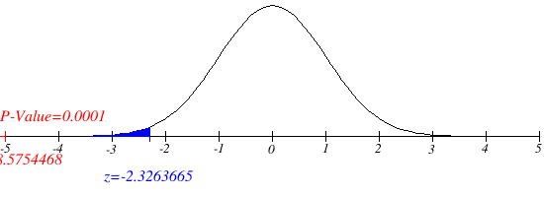P-Value for Left Tail Hypothesis = 4.9695E-18

|  |  |
| --- | --- |
| Alpha | Critical Value |
| 1% | -2.3263665 |
| 5% | -1.6448612 |
| 10% | -1.2815558 |

**Figure 1: Represents Left Tailed Test Type At t-value (alpha=1%) (Hypothesis Test Graph Generator, n.d.)**

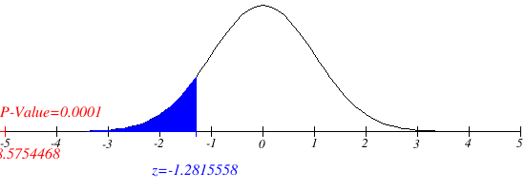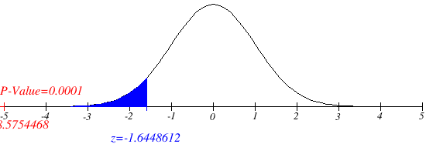**Figure 2: Represents Left Tailed Test Type At t-value (alpha=5%)(Hypothesis Test Graph Generator, n.d.)**

**Figure 3: Represents Left Tailed Test Type At t-value (alpha=10%) (Hypothesis Test Graph Generator, n.d.)**

**Left-Tailed Graph Explanation:** The diagrams 1, 2, and 3 above illustrate a left-tailed test hypothesis with a normal distribution. For a left-tailed test at alpha = 1% the critical value is -2.3974, alpha = 5%, is -1.6736 and alpha = 10% it is -1.29743. The test statistic value is –8.5754468 and the p-value is 0.0001.

**Interpretation**: Since the P value (0.0001) is less than alpha (1, 5, and 10%), we reject the null hypothesis. This means we have strong evidence to reject the null hypothesis and support the alternative hypothesis. Rejection of the null hypothesis implies strong evidence in favor of the alternative hypothesis, which shows that the true mean profit for the entire population is less than 30.

**For The Right Tail Hypothesis**

**Null Hypothesis: H0<=30**

**Alternative Hypothesis: Ha>30**

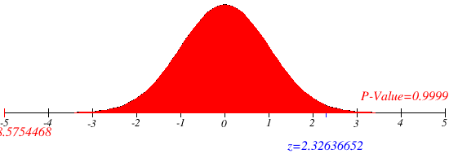P-Value = 1

|  |  |
| --- | --- |
| Alpha | Critical Value |
| 1% | 2.32636652 |
| 5% | 1.64486125 |
| 10% | 1.2815558 |

**Figure 4: Represents Right Tailed Test Type At t-value (alpha=1%) (Hypothesis Test Graph Generator, n.d.)**

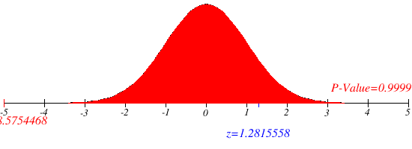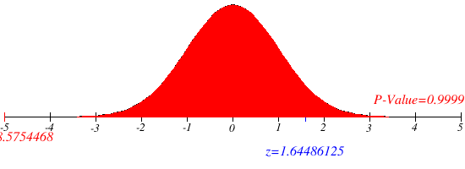**Figure 5 Represents Right Tailed Test Type At t-value (alpha=5%) (Hypothesis Test Graph Generator, n.d.)**

**Figure 6: Represents Right-Tailed Test Type At t-value (alpha=10%) (Hypothesis Test Graph Generator, n.d.)**

**Right-Tailed Graph Explanation:**

The diagrams 4, 5, and 6 above illustrate a right-tailed test hypothesis with a normal distribution. The critical value for a right-tailed test at alpha = 1% is 2.32636652, alpha = 5% is 1.64486125, and alpha = 10% is 1.2815558. The test statistic value is –8.5754468.

**Interpretation:**

Since the p-value is very high (0.9999), which is greater than alpha, this means that there is very strong evidence for not rejecting the null hypothesis. This means we "fail to reject the null hypothesis", meaning we can conclude that there is not enough evidence to reject the null evidence that the average return for the entire population is smaller than or equal to 30.

For The Two Tail Hypothesis

Null Hypothesis: H0: μp=30

Alternative Hypothesis: Ha: μp ≠ 30

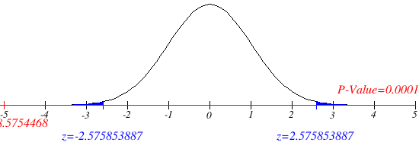P-Value = 9.93930E-18

|  |  |
| --- | --- |
| Alpha | Critical Value |
| 1% | 2.575853887 |
| 5% | 1.959975846 |
| 10% | 1.644861246 |

**Figure 7: Represents Two-Tailed Test Type At t-value (alpha=1%) (Hypothesis Test Graph Generator, n.d.**

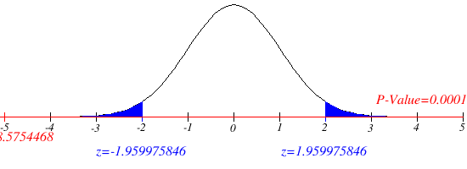

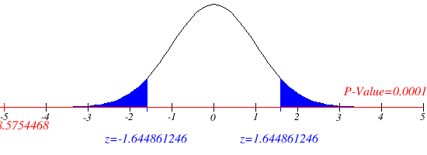**Figure 8: Represents Two-Tailed Test Type At t-value (alpha=5%) (Hypothesis Test Graph Generator, n.d.)**

**Figure 9: Represents Two-Tailed Test Type At t-value (alpha=10%) (Hypothesis Test Graph Generator, n.d.)**

**Two-Tailed Graph Explanation:**

The diagrams 7, 8, and 9 above illustrate a two-tailed test hypothesis with a normal distribution. The critical values ​​for the two-tailed test at alpha α = 1% are 2.575853887, at alpha α = 5% are 1.959975846, and at alpha α = 10% are 1.644861246 The test statistic value is -8.57544685 and the p-value is 0.0001, which is less than alpha.

Interpretation: Since the P-value (0.0001) is less than alpha, it means we reject the null hypothesis. Rejecting the null hypothesis provides strong evidence in favour of the alternative hypothesis, indicating that the true mean profit for the entire population is 30.

**Recommendations:**

**Enhance Financial Reporting and Management:** Microsoft should review and enhance its financial reporting to ensure accuracy and transparency. This includes conducting regular audits and implementing robust internal controls. This also includes analyzing financial performance in more detail and adjusting strategies as needed.

**Products Choice:** Microsoft should focus on products and services that bring more profit to the company like Azure, Xbox, and Office, and focus less on experimental projects. This would help stay ahead of the market curve.

**Conclusion:**

The findings of the t-test analysis provide valuable insight into Microsoft's profit performance and the accuracy of the company's financial reporting. By addressing these setbacks and implementing recommended actions, Microsoft can improve its profit margin and maximize the market.

**Part B**

The true population is 130. All the 10 intervals contain the true population mean of 130. The intervals contain a true population mean of 130 because, for each of these intervals the true mean is within the range defined by their lower and upper bounds. This means that the true mean is greater than or equal to the lower bound and less than or equal to the upper bound of each of these intervals. For each of these intervals, the true mean of 130 is included in the range defined by the lower and upper limits. As seen in the diagram below where all the sample mean contains the true population mean.

|  |  |  |  |  |  |  |
| --- | --- | --- | --- | --- | --- | --- |
| Sample | Mean | Standard Deviation | Sample Size | Margin of Error | Lower Limit | Upper Limit |
| 1 | 127.394559 | 11.4820155 | 29 | 4.3675251 | 123.027034 | 131.762084 |
| 2 | 126.645446 | 12.6478719 | 29 | 4.81099318 | 121.834452 | 131.456439 |
| 3 | 131.418138 | 9.3431483 | 29 | 3.55394355 | 127.864194 | 134.972081 |
| 4 | 127.928407 | 10.7464334 | 29 | 4.08772465 | 123.840682 | 132.016132 |
| 5 | 129.865231 | 12.1832806 | 29 | 4.63427209 | 125.230959 | 134.499503 |
| 6 | 124.913284 | 14.1717406 | 29 | 5.39064183 | 119.522643 | 130.303926 |
| 7 | 127.500321 | 8.93143307 | 29 | 3.39733545 | 124.102985 | 130.897656 |
| 8 | 128.530721 | 12.5290942 | 29 | 4.76581254 | 123.764908 | 133.296533 |
| 9 | 127.369524 | 8.16855038 | 29 | 3.10715039 | 124.262374 | 130.476675 |
| 10 | 127.608547 | 11.4704808 | 29 | 4.36313757 | 123.245409 | 131.971684 |

**REFERENCES**

iMathAS. (n.d.). Hypothesis Test Graph Generator [Computer software]. Retrieved from <https://www.imathas.com/stattools/norm.html>

Patel, S. (n.d.). Heights and Weights Dataset. Kaggle. Retrieved March 6, 2024, from <https://www.kaggle.com/datasets/burnoutminer/heights-and-weights-dataset>.